SWED Exercise 1
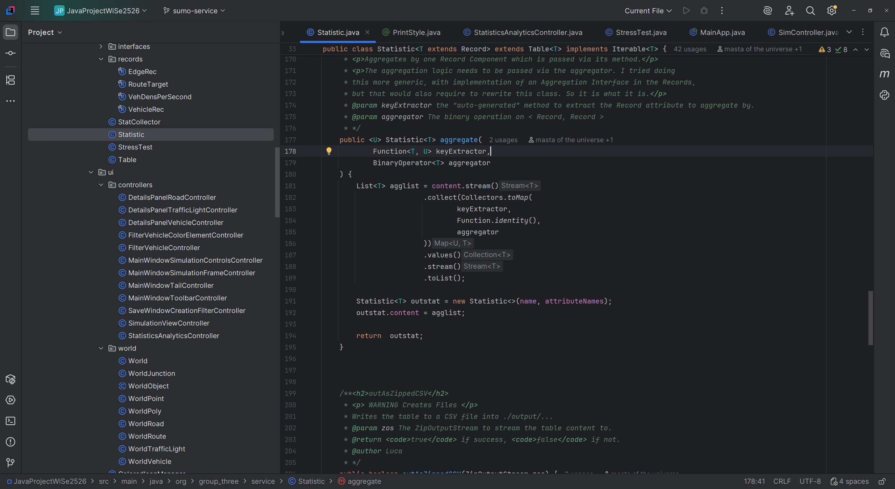

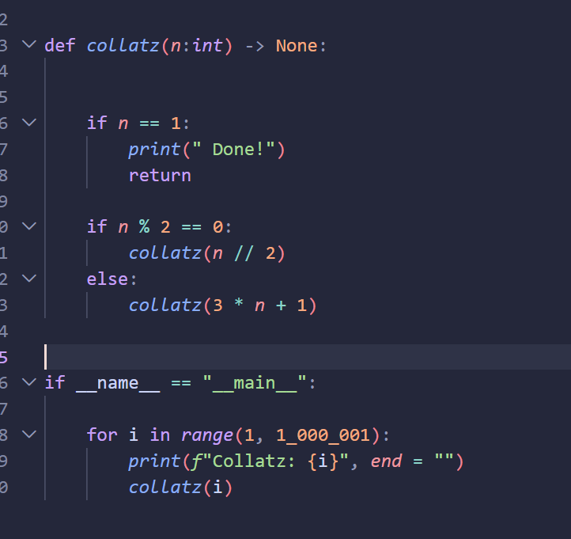

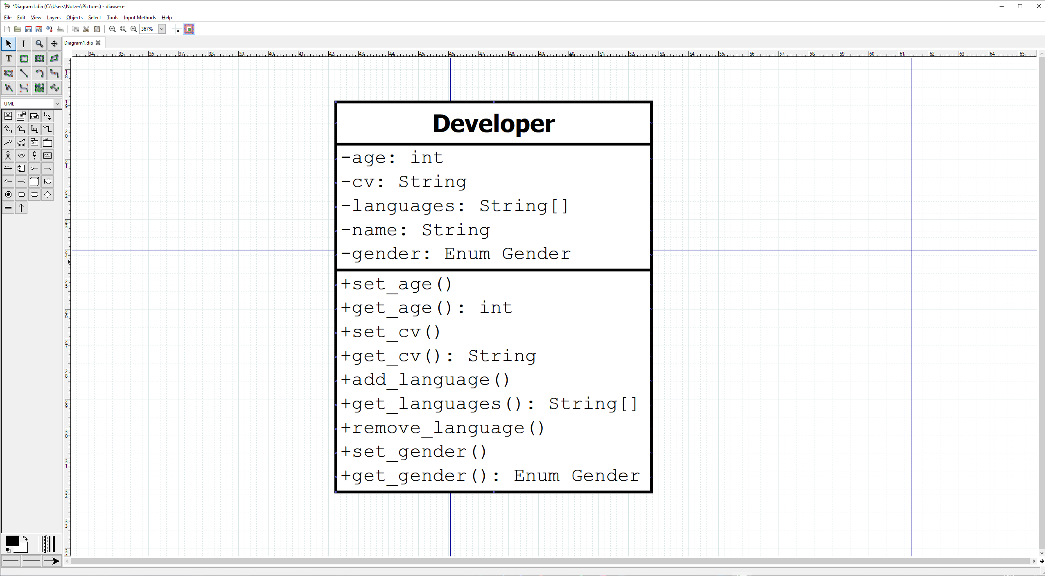

  - 6
SWE-D tries to make the User experience as efficient and pleasant as possible.
SWE-A tries to make the work of the program itself as efficient as possible.
  - 7
The Design-Part of a software project is important, because it defines how pleasant and efficient the User experience is. This means that when this part is not done correctly (or not done at all) the program may (and probably will) experience huge Frontend-Experience problems, leading to Problems when using the Program as a user.
  - 8
Yes.
Architectural Design effects the developers of the Program.
Database Design effects how data is processed and queried inside the Program.
User Interface Design effects how the User perceives and uses the Program.
They are independent from each other, as they all serve different kinds of people.

